Spark Session

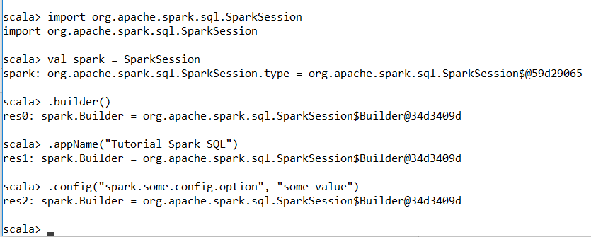

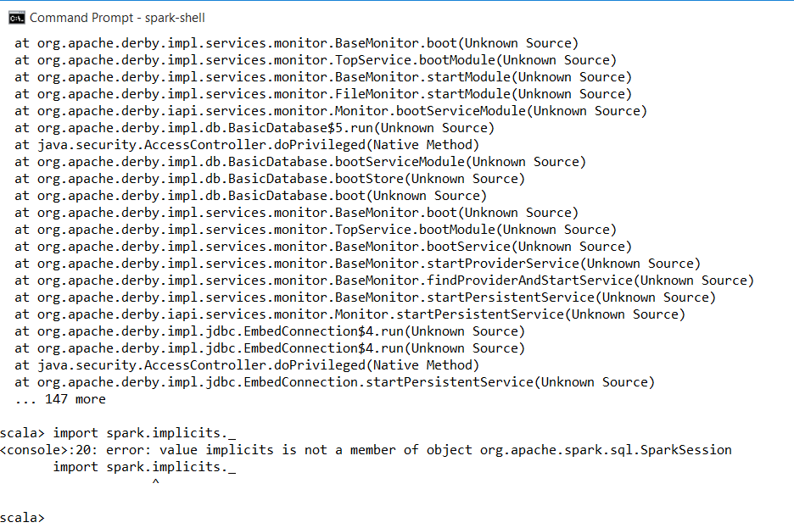

**Creating DataFrames**

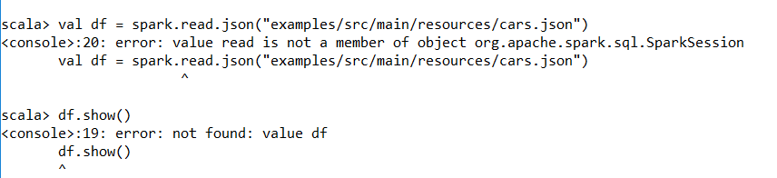

## Untyped Dataset Operations (aka DataFrame Operations)

